EMAIL NOTIFICATION SYSTEM

The email notification system is a separate module sold that provides email notification.
Initial cost will be $500, however this may increase as more email notification features are added. Once this module is purchased, all future enhancements are included.

The first program with this logic is the advanced ship notice via bill of lading printing.
As more options are added a similar toggle box will appear on the printing routine.
For example, when printing a purchase order, you may want to simultaneously email an advanced email notification. I am sure our clients will think of more creative issues.
Perhaps email notification when finished goods have been produced letting the customers know they are ready to be shipped once you receive an official release. Likewise, when an item falls below a reorder point, an email may be sent to notify production, sales service, the purchasing agent and / or the warehouse manager.

The bill of lading shipment email notification system requires building a few files.
First, contacts must be added for each ship to location in the customer file.
First, select the customer ship to location, then press the phone icon.

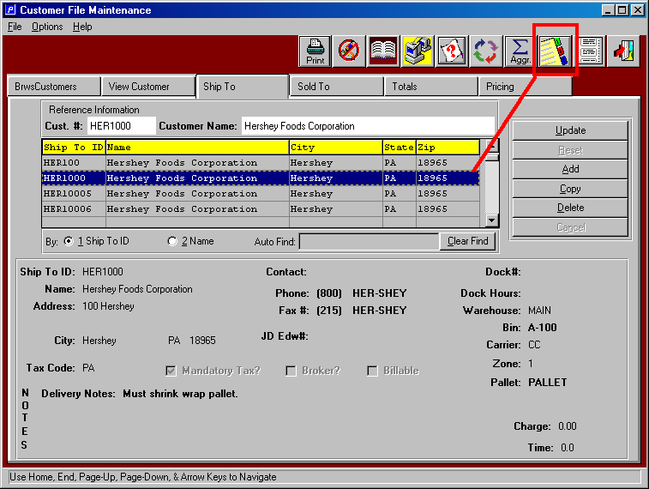

Next, add contacts to specific ship to locations. Make sure you check the check the toggle box called E-Mail Notification. This will automatically check the Bill of Lading option. Other programs will be available to invoke the email notice logic as we make the changes. However, must will be determined by the customer phone icon, not be ship to location.

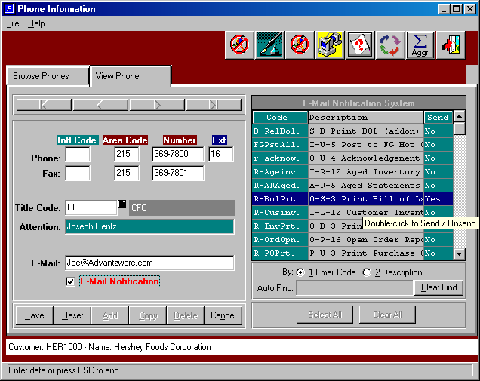

Next step for bill of lading advanced notification is to add the specific contacts to the ECODES file under the bill of lading program.

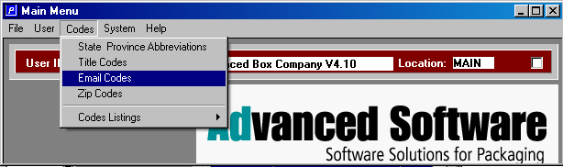

Then select the Bill of Lading program and click the SHIPTO contacts folder.
Please note, the Customer Contacts may be used in combination with the output to email, however this will not work in batch mode or by ship to location. Hence, you could define a master contact for all bill of ladings, and specific contacts by ship to location.
Click the SHIP CONTACTS folder to assign contacts to receive the advanced email notification when printing bill of ladings.

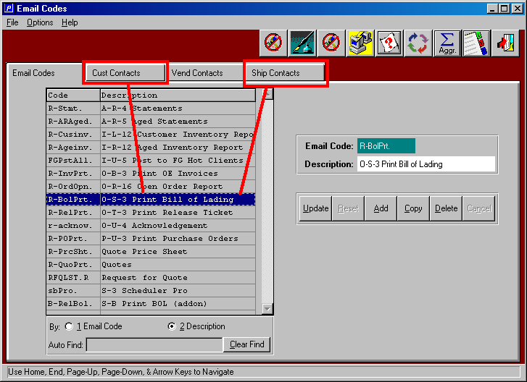

Adding contacts has many ways to search for specific customers or contacts by customer, title, name or attention.

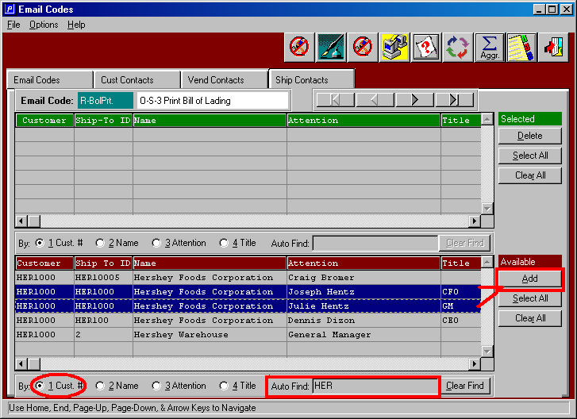

Once you find the contacts from the customer’s ship to file, click the ADD button and the contacts will transfer to the Green bar where selected contracts reside.

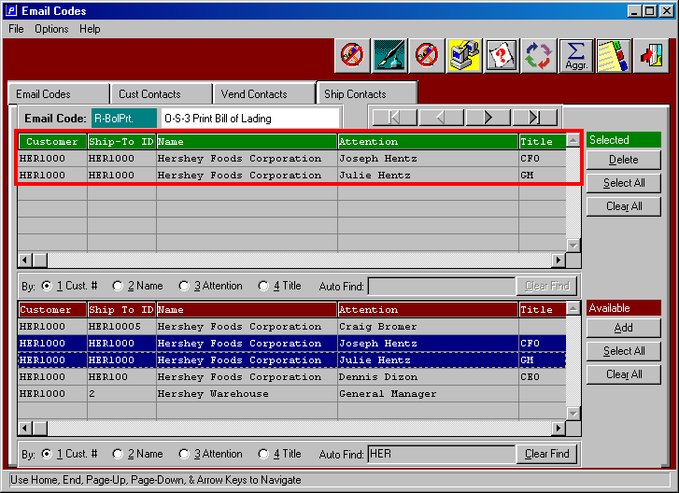

Note the new toggle boxes called Email Advanced Ship Notice, Hide Email Dialog Box and Preview Form / Report. The preview form option will display the business form as if the output was going to the screen. When the Hide Email option is checked, the email dialog box which displays the Send to and Subject Topic will run in background.
When unchecked, you must click the send button for each email ship to location.
When first getting familiar with this feature, you may want to options listed below.

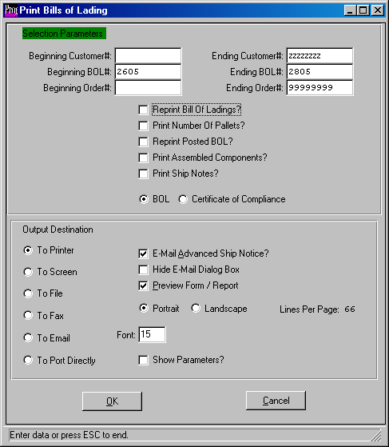

Once you click the OK button, the system will process all the bill of ladings. This process will batch the bill of ladings into one singe .PDF format indicating the range of bill of ladings in the text message section of the email. Notice, the system automatically, selected the ship to contacts for this ship to location.

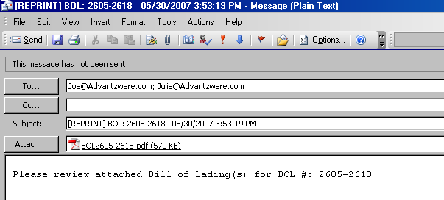

Finally, since we clicked the preview form, the document is displayed prior to creating the email. Please note, this button is not needed if you do not click the HIDE email dialog box, because you can view the attachment prior to sending the email.

You will notice the attachment has combined all the bill of ladings for this ship to location into one single attachment. The page numbers listed at the bottom indicate the total number of bill of ladings. Each click of the arrow key at the bottom will display a different bill of lading for this specific ship to location.

